**Project -- GDD**

**COSC 419 I Game Engineering**

**2016/17 T2**

**Student Name Student Number**

Ryan Kramer 24604143

Kevin Van Kessel 37845138

Ryan McQueen 54198149

Overview

Theme / Setting / Genre

Core Gameplay Mechanics Brief

Targeted platforms

Monetization model (Brief/Document)

Project Scope

Influences (Brief)

- <Flame In the Flood>

- <Diablo 3>

- <Clash of Clans>

The Elevator Pitch

Project Description:

Core Gameplay Mechanics (Detailed)

- <Player Survival>

- <Looting and Crafting>

- <Combat>

- <Player Bases>

Story and Gameplay

Story (Brief)

Story (Detailed)

Gameplay (Brief)

Gameplay (Detailed)

Assets Needed

- 2D

- 3D

- Sound

- Code

- Animation

Schedule

- <Project Milestone 2/First Prototype>

- <Project Milestone 3/ Working Demo>

- <Final Product>

# Overview

## **Theme / Setting / Genre**

- The game is a fantasy setting survival/action game where the player escapes a island filled with monsters and a dangerous environment

## **Core Gameplay Mechanics Brief**

- Player manages food/water/illness while fighting their way to victory

- Player finds loot and can use or combine it to make better gear/items

- A homebase with workers auto-gathers basic items to reduce grinding

- Further areas are more deadly, but offer better gear and items

## **Targeted platforms**

- PC, Mac, Linux

## **Monetization model (Brief/Document)**

-One time purchase on buying game

## **Project Scope**

- <Game Time Scale>

- No costs involved in production (free game engine, unpaid work)

- 1 month for demo, 3 months for full game

- <Team Size>

- <Core Team>

-Ryan Kramer: Lead Programmer

-Ryan McQueen: Programmer

-Kevin van Kessel: Designer

- <Licenses / Hardware / Other Costs>

-Unity 5.5.1.f1 free version

## 

## 

## **Influences (Brief)**

### **- <Flame In the Flood>**

- PC video game

- fun survival game focused more on environmental dangers than actual combat

### **- <Diablo 3>**

- PC video game

- Fun, simple and easy to implement combat system that works well with varying items and weapons

### **- <Clash of Clans>**

- Mobile video game

- automatically increases resources so the player always moves forward, but amount is low enough to encourage player to manually play and gather more resources to move faster.

## **The Elevator Pitch**

A game where the player is trapped on a island and goes around to various environments filled with loot, enemies and environmental dangers that the player braves to get the loot, which they then use to craft better gear to survive to farther, more dangerous areas. It’s a simple to make, but addicting game that constantly rewards the player while also offering a challenge if the player dares to go into the farther out locations.

## **Project Description:**

This project is a small, relatively simple game being made by three programming students in their free time, which results in a fair amount of quality code and game systems, but relies on free use visual and audio assets such as 3D models and sound effects, which may not fit as well as they could if made by a professional for the game.

What sets this project apart?

* Constant progress forward and player reward through grinding easy zones for loot and automatic resource gathering via main base

- Interesting mix between managing survival aspects like food/water, as well as dealing with more immediate dangers such as enemies and hostile environment

- Moving between 3D areas on a 2D world map gives players interesting 3D levels without the time consuming open world environments, as well as giving each area a unique theme

## **Core Gameplay Mechanics (Detailed)**

### **- <Player Survival>**

- <Details>

Players have to manage resources such as food, water and illness in addition to the more immediate threats the environments provide. The player has to try to prevent, or quickly cure illnesses through items they find or craft. Food and water constantly drain and needs to be replenished through the use of consumable items otherwise the player starts to be negatively affected.

- <How it works>

The player food and water meter slowly decrease over time and while traveling between areas in the overworld. The player has to replenish these meters through the appropriate consumable items (food items, water) otherwise they start to get negative effects, starting with a weakened state which has the player move slower, deal less damage and take more damage. When one of the bars is completely empty, the player starts losing health until the bar is filled again or the player dies. These effects increase in effectiveness when both food and water bars are low/empty. Food and water is automatically refilled for free when the player returns to their home base, and the homebase automatically finds basic food and water consumables to be taken.

The player can be afflicted with varying illnesses when exploring the areas, most of which can be avoided by a skilled player (such as avoiding a poison cloud), though some just occur randomly in the further areas. The effects of illnesses vary from dealing low damage over time, draining food or water faster, or making the player unconscious (which causes the player to lose some food/water meter and some items in their inventory). Illnesses generally have no or minor effects to begin with, but grows more severe with time, and thus should be cured sooner rather than later. Illnesses can be cured through medicine found or crafted by the player, there is one medicine that works for all illnesses and makes the player immune to further infection for a time, but the medicine is rare and expensive to craft, so care should be taken to avoid illness when you can.

### **- <Looting and Crafting>**

- <Details>

As the player explores the 3D levels, they find various loot crates and loot dropped by slain enemies that contain items the player can pick up for themselves. The loot varies from weapons and armor to consumable items to crafting supplies. The quality of the loot varies depending on the loot craft quality (set by level designers), the difficulty of the enemy killed, by the level difficulty and if this is the first time the area is explored.

Crafting works by the player having a crafting menu that displays each item the player can make, with items that can be made with the items the player currently has being highlighted and placed at the top of the menu. Hovering over a craftable item shows what's needed and how much of it is needed. Some crafting can only be done at the home base, such as advanced weapons or unique items.

- <How it works>

The first time the player explores a area, that area has a higher loot quality and quantity, but after exploring the area subsequent times, the loot quality and quantity decrease to encourage going to other areas, while still having basic loot and crafting materials for grinding if the player is behind. Level Difficulty: areas further away from center of map have better loot, but are more dangerous. Crafting: When the player clicks one of the items they could make, the items needed to make the item are automatically removed from the player's inventory and the new item is added to their inventory.

### 

### **- <Combat>**

- <Details>

Combat is relatively simple in that when the player clicks the mouse, the player attacks with whatever weapon they have equipped (if no weapon, player uses fists with very low attack value). The players attack varies depending on the weapon equipped, some weapons such as swords attack everything in a short arc in front of the player, while a lance would have a long thin hitbox in front of the player. In addition the player may have ranged weapons, which require ammo in the player's inventory to fire, but have a very longer range. When the player attacks a enemy, it takes the players damage minus the enemy's defense and subtracts that difference from the enemy's health, this system is also used when the enemy attacks the player. Depending on the enemy, the enemy will either run to the player and attack when close enough or attack from range as soon as the player enters their detection radius. The player can replenish health instantly through consumable health items, or gradually if their food/water meters are high enough

- <How it works>

Ranged weapons auto-consume ammo when fired by searching the player's inventory for the ammo that matches the weapon fired, and takes one ammo away if fired. If there is no ammo matching the weapon fired, the weapon is not fired and player notified they have no more ammo for that weapon. Weapons only affect two things in combat, the player's attack value which is the player's base dmg plus the weapons dmg, and the players attack hitbox, which varies in shape, angle and length depending on the weapon. Player armor just increases the player's defense, decreasing damage taken by their defense value.

### **- <Player Bases>**

- <Details>

The homebase is the player's home in the game, and is centered in the middle of the game map. The base allows the player to craft all craftable items, replenishes food and water for free, cures the players illnesses and heals the player. The base also has automated workers that gather basic items and crafting materials for the players use. These workers can be assigned to gather specific things more than others, for example the player can tell them to focus on gathering food, but that means they will find less of other items. The workers automatically find items while the player plays the game, regardless of what the player is doing. If there is time to do so, the base will be upgradable with loot to improve things such as worker quality or speed, another thing that might be done is to have the base come under attack sometimes, and while right now there is only one base planned in the center of the map, we may add additional outpost style bases if there is time.

- <How it works>

Workers automatically gather items and crafting supplies that go into storage at the base, when the player visits the base, they can see what the workers have gathered and move them into their own inventory, or leave it in storage. New items gathered since the player viewed the storage inventory will be highlighted and displayed before the other already seen loot.

# Story and Gameplay

## **Story (Brief)**

Player ends up stranded on a dangerous island filled with monsters and dangerous environments, but also has rare items. The player was teleported to the center of the island by a evil witch, and finds out the only way to escape is to make a flying machine from parts scattered around the island.

## **Story (Detailed)**

The plot begins with the player on a merchant boat carrying a bunch of treasure, items and stuff in general, when a witch appears and teleports the boat high above her island. The boat crashes down onto the middle of the island, and the player plays as the sole survivor of the crash. The merchant boat crashing and throwing its cargo across the island explains the loot crates and basic supplies found throughout the game. The player soon finds a group of magical dolls/golems the witch made that follow any instruction given, at which point the player tells them to make a shelter and find him a way off the island, at which point the player goes around exploring a bit (which is the tutorial level). When the player returns he see’s the workers made a whole outpost and give him a blueprint for a flying machine, which is the only way off the island and instruct the player where they can find the key parts needed to build the flying machine. The workers (which have no combat capabilities) are put to work gathering supplies by the player. The player then goes from area to area gathering loot, crafting better gear and items to get to the furthest areas which contain the key parts needed to escape. Once all pieces are gathered and brought back to the home base, the player escapes and wins the game. If there is time there may be a boss fight with the witch who brought you here, otherwise the player just escapes.

## **Gameplay (Brief)**

Player goes from area to area exploring the areas for loot the player then uses to craft better gear and items needed to survive the more dangerous, out levels of the map, which need to be traversed to get to the key parts the player needs to win the game.

## **Gameplay (Detailed)**

The player starts on the 2D overworld map which shows the nearest visitable areas and the homebase, clicking on a area takes the player to that area, if its homebase the player is taken to the homebase menu, otherwise it is a level and the game goes to the 3D level and places the player model at the start point of the level. The player can see one level of areas the player cannot travel to yet, as the previous area must be traversed to access the areas beyond it. These areas the player cannot travel too are a very dark grey or black to indicate the player cannot go there yet, but the player can infer what levels need to be done to get to those further levels. The player can skip the levels of areas they have already cleared by clicking on areas further away, and the player will go through, but not visit areas between them and the goal area.

Homebase is currently just a series of menus, such as instructing workers to focus on a type of gathering, looking at the inventory/storage and crafting items. If there is time, though of low priority, the homebase may be converted to a 3D level the player traverses to do the different functions of the base (visiting the storage building to access the storage for example).

The 3D areas are areas that the player traverses using wasd to move and q,e to rotate the camera around the player. The player is blocked by large objects such as trees,boulders and walls, but not smaller stuff like bushes or small rocks. Enemies will be placed around the level by the level designers, and generally don’t move, though if there is time basic patrolling patterns may be incorporated. Enemies will start chasing players when the player gets close enough, each enemy has their own detection box, so pulling one at a time is possible. Enemies have pathfinding AI and will follow the player forever until killed or they killed the player. Once the enemy is close enough to the player, they will stop and start attacking the player (enemies stop when close enough because the AI has them circle the player otherwise, which while funny doesn't look right). When the enemy or player attacks, they activate their hitbox which automatically deals damage to anything inside the hit box using the formula defense.hp - (attacker.dmg - defender.defense). Hostile environment features start appearing more as the player gets to the later levels and include things such as poison clouds, snakes and falling boulders, the effects of which are generally triggered when the player enters a certain area near the feature. This means some areas can be avoided (snakes hissing, see poison clouds), while other non-noticeable features can be avoided before the repercussions occur (falling rocks), every hostile environment feature can be dealt with in some way, be in avoiding it or dealing with it.There are multiple loot crates scattered around the level, and when the player gets close enough to one, a prompt appears above the box with the button to press to open the box, this opens the loot inventory UI, at which point the player can open their own inventory or character sheet and move items between the menus. Items put in a loot box don’t change if opened and left, except in the case the player leaves the level entirely, at which point items left behind are lost, and new loot will be placed when the user reenters a area.

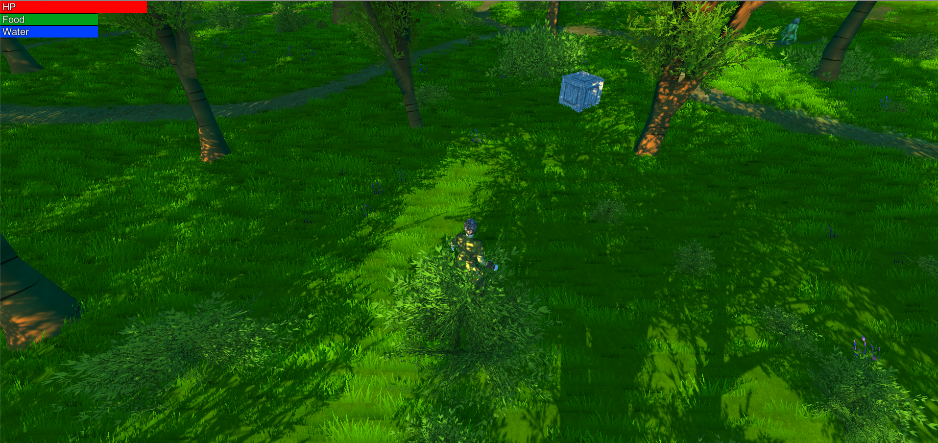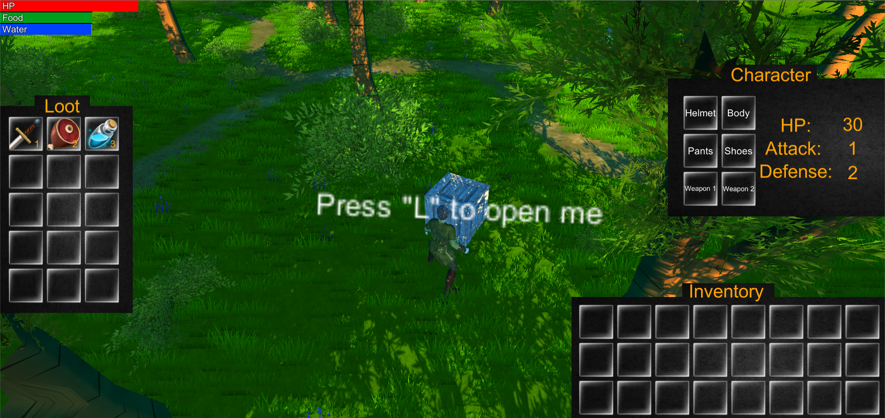

# *UI of Gameplay*

# 

# Assets Needed

## **- 2D**

- Textures

-Simple sprite icons for inventory items

-Overworld screen featuring a old fashioned map in the background

-Level Icons indicating level type (ex: forest icon for forest level)

-Menu UI and buttons

## **- 3D**

- Characters List

-Player Character - medieval/fantasy type

-Enemies - fantasy monsters

-If time - NPC characters (shops, workers,etc)

- Environmental Art Lists

- Level Terrain

- Environment features (trees,bushes,ruins,etc)

- Interactive Elements (loot crates, hostile environment)

## **- Sound**

- Sound List (Ambient)

- Background noise associated with level type (birds chirping/quiet noises in forest, whistling winds in desert or mountain,etc)

-Noises made by hostile environments (snakes hissing, poison clouds making whooshing noise)

- Sound List (Player)

- Character Movement Sound List

-Character Attacking (weapon swoosh noises)

-Character Moving (quiet footsteps)

- Character Hit / Collision Sound list

- Pain Noise when hit

- Death Noises on death

- Sound List (Other)

-Opening loot (creaking noise for loot crate, opening bag noise for enemy loot,etc)

-Menu and UI sound effects (clicking a button, equiping gear, moving items)

-Main Menu music

-If Time - music that plays when in combat

## **- Code**

- Character Script (Player Controller, Player Inventory)

- Ambient Scripts (Runs in the background)

-Inventory management

-boundaries of level

- NPC Scripts

- Enemy Scripts (Player tracking,attack conditions,etc)

## **- Animation**

- Environment Animations

- hostile environments (poison clouds swirling, snakes slithering

- IF time - environmental animations such as tree’s swaying

- Character Animations

- Player

- Blend tree for movement (forward,backwards,left,right,idle)

-Attack animation

-Hit/death animations

- NPC

- Attack/being hit/death animations

-Idle animations while player undetected

# 

# Schedule

### **- <Project Milestone 2/First Prototype>**

- 2 Weeks

- Basic/most important features implemented

- Player movement,attacking

- loot crates and inventories working

-needed menus and UI working

-Basic animations for movement,attacking

-equipping gear affects player stats and appears ingame

-basic combat works

### **- <Project Milestone 3/ Working Demo>**

- 2 weeks

- One or more levels fully complete

- all weapon types implemented

- overworld area traveling

-basic crafting

-homebase basic functions (worker gathering)

-hostile environment features

-survival aspects active (food/water)

-consumable items and crafting supplies/more items

-everything needed for early game levels fully functional

### **- <Final Product>**

- 1 month

- all serious bugs gone, most other bugs gone

- all levels done

- all features up and running

-Bonus features implemented if time